[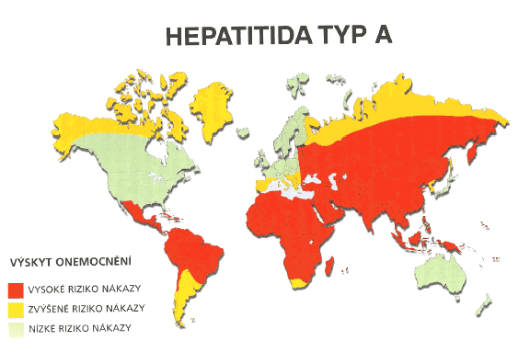](http://www.google.cz/url?sa=i&rct=j&q=&esrc=s&frm=1&source=images&cd=&cad=rja&docid=AO9D9RmOVYoOHM&tbnid=wR81gcD2jtS7vM:&ved=0CAUQjRw&url=http://www.zdravinacestach.cz/index.php?/dalsi_onemocneni/hepatitida_a_b&ei=nvgJUuP_KMmRtQbpm4CoDQ&bvm=bv.50500085,d.Yms&psig=AFQjCNGeJyBtsQqHPaectCEA8UkRhiPO4Q&ust=1376471571176686)

[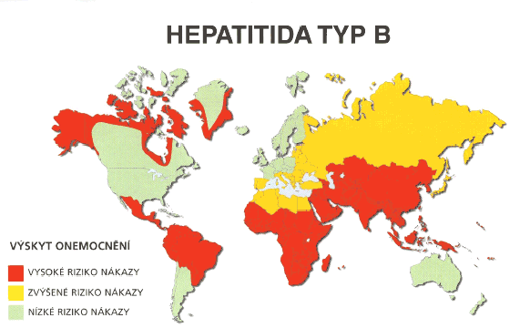](http://www.google.cz/url?sa=i&rct=j&q=&esrc=s&frm=1&source=images&cd=&cad=rja&docid=AO9D9RmOVYoOHM&tbnid=BbXhVTO2KbL_5M:&ved=0CAUQjRw&url=http://www.zdravinacestach.cz/index.php?/dalsi_onemocneni/hepatitida_a_b&ei=0PgJUsWDEdD2sgbR4IDoBg&bvm=bv.50500085,d.Yms&psig=AFQjCNGeJyBtsQqHPaectCEA8UkRhiPO4Q&ust=1376471571176686)